**EXPERIMENT NO –16::**

**STIMULATION OF A MULTIMEDIA NETWORK.**

**AIM:**

**STIMULATION OF A MULTIMEDIA NETWORK IN CISCO PACKET TRACER.**

**Procedure ::**

1.open the cisco tracer .

2.Then select the pc’s from the network devices,and also printer T,switch.Then arrange them in the particular order as below.

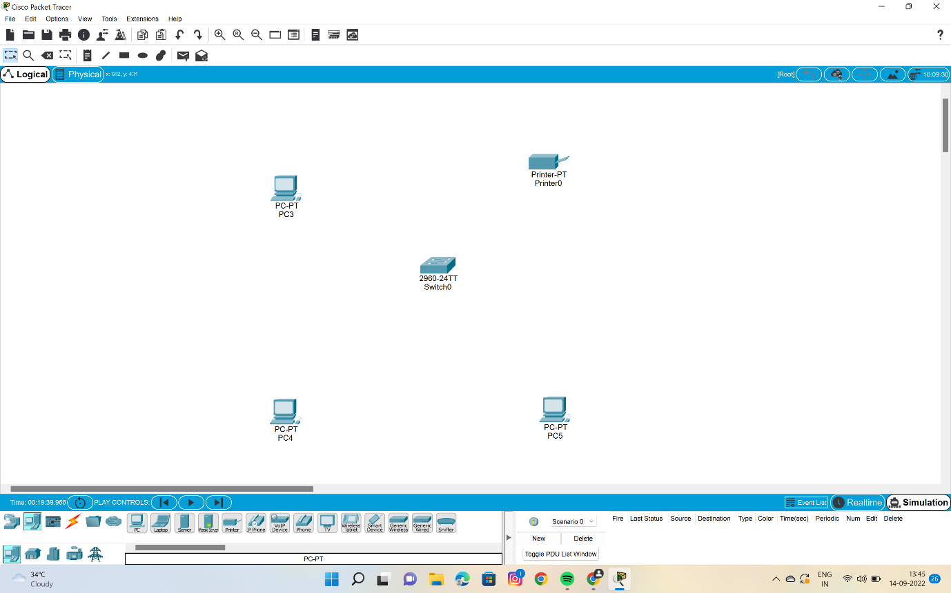

3.Establish the connections between them clearly.

4.Provide the ip address for the 3 pc’s and as well as the printer T .

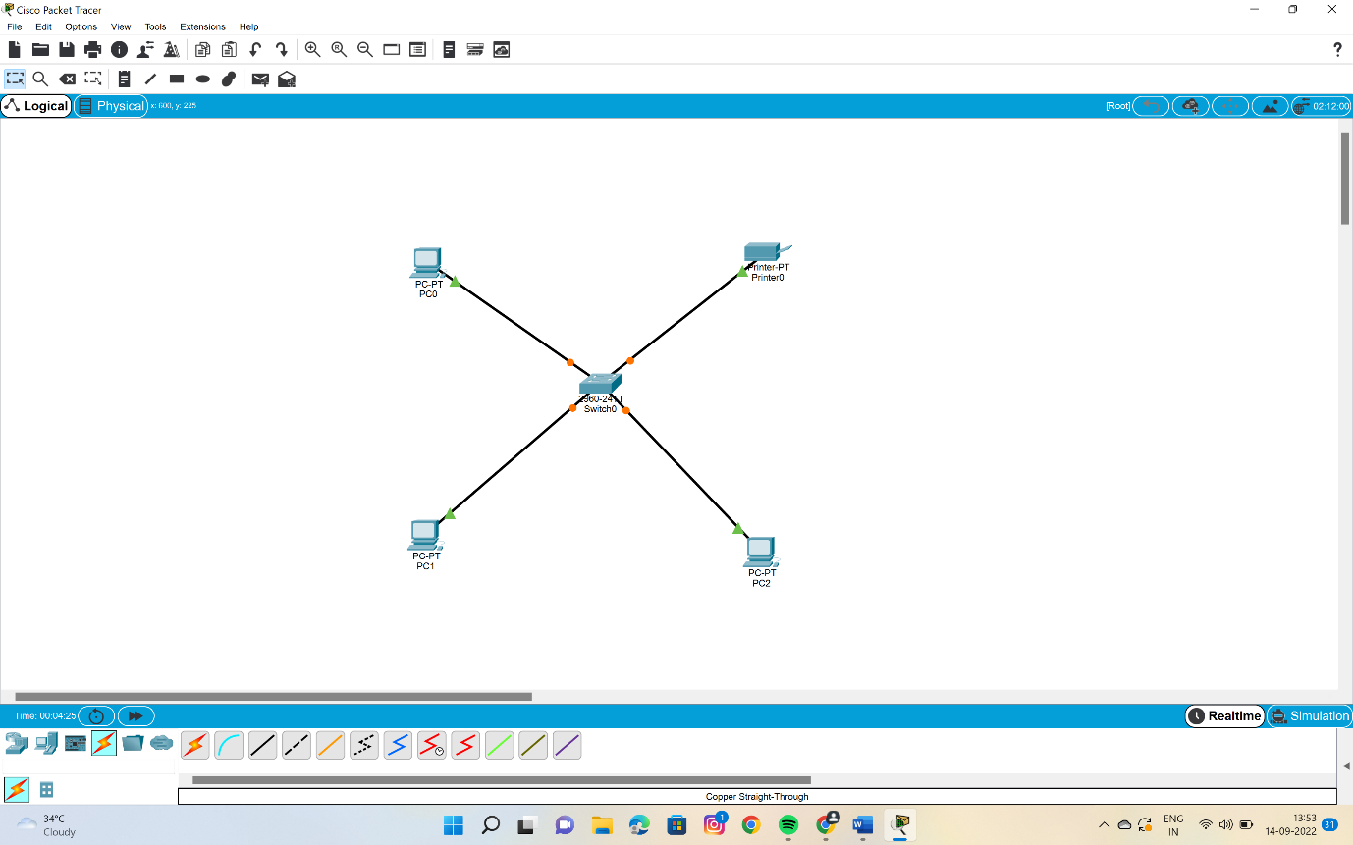

5.Then move to the pc and click on it—give host 1 as the display name—click physical –then connect the head phones and micro phones to the physical cpu.shown as below.

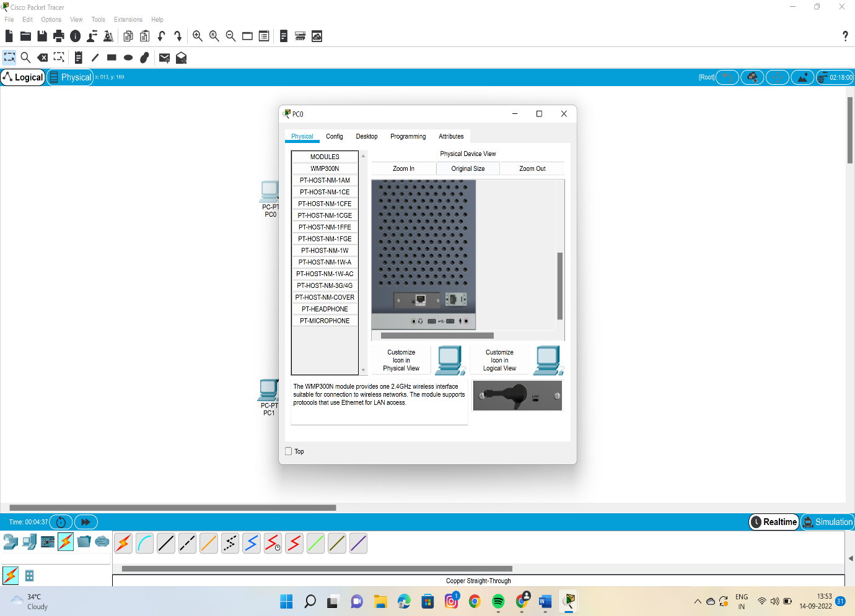

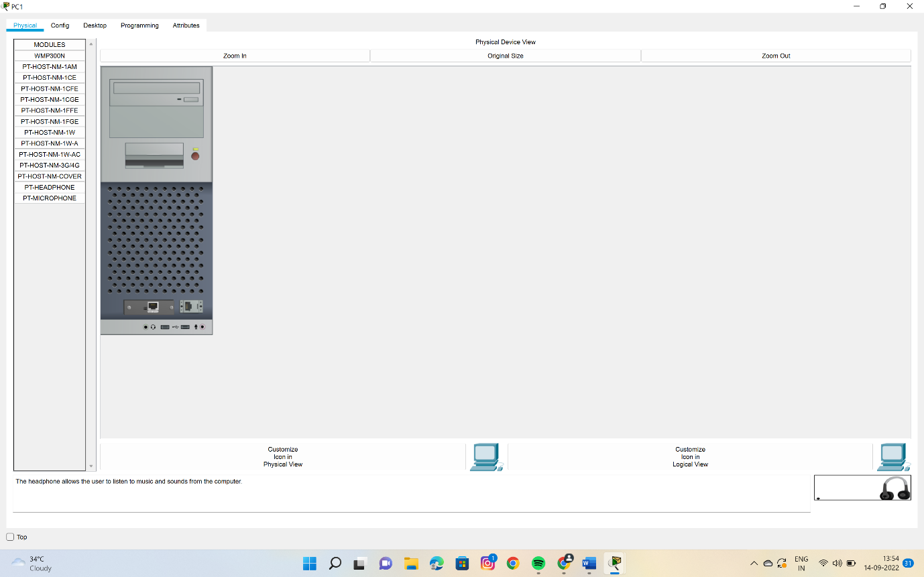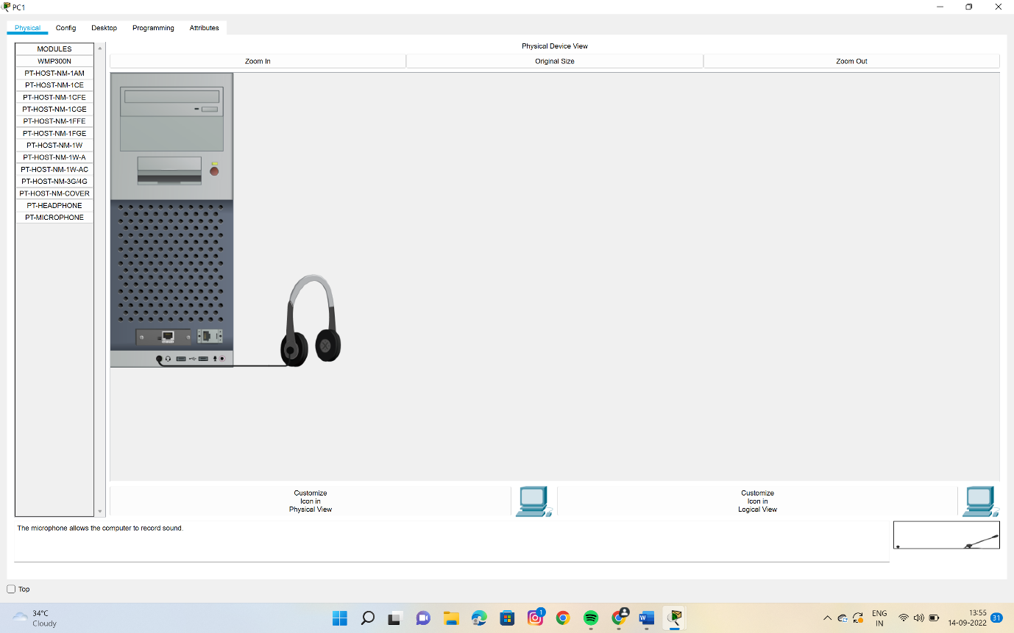

6.Do the same to the remaining pc’s also.

7.click on the printer –configure --fastether0— give ip address.shown below

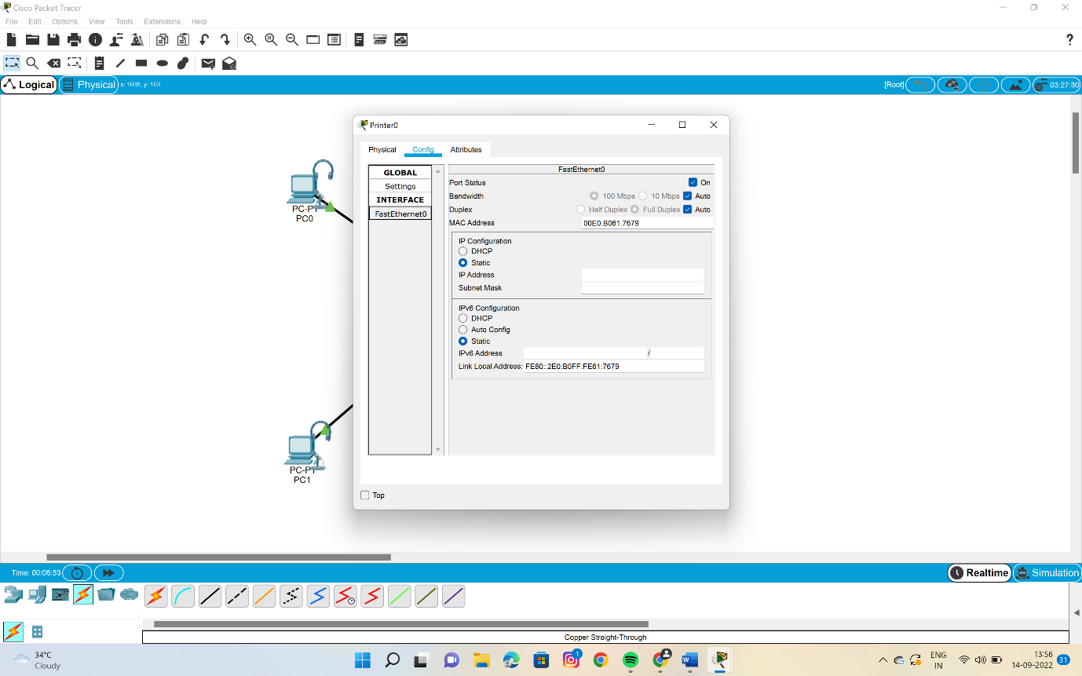

8.now everything is set .go to the command prompt in any pc and ping the command as below.

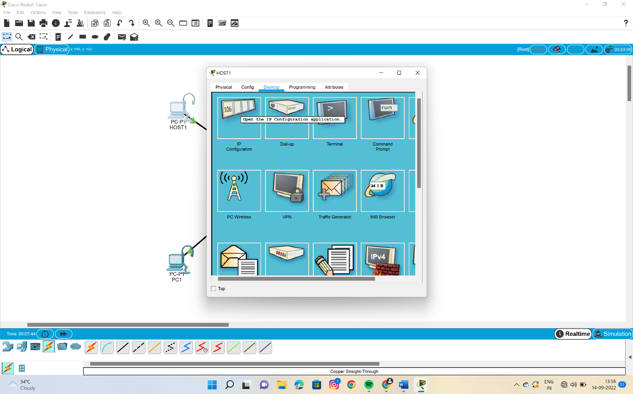

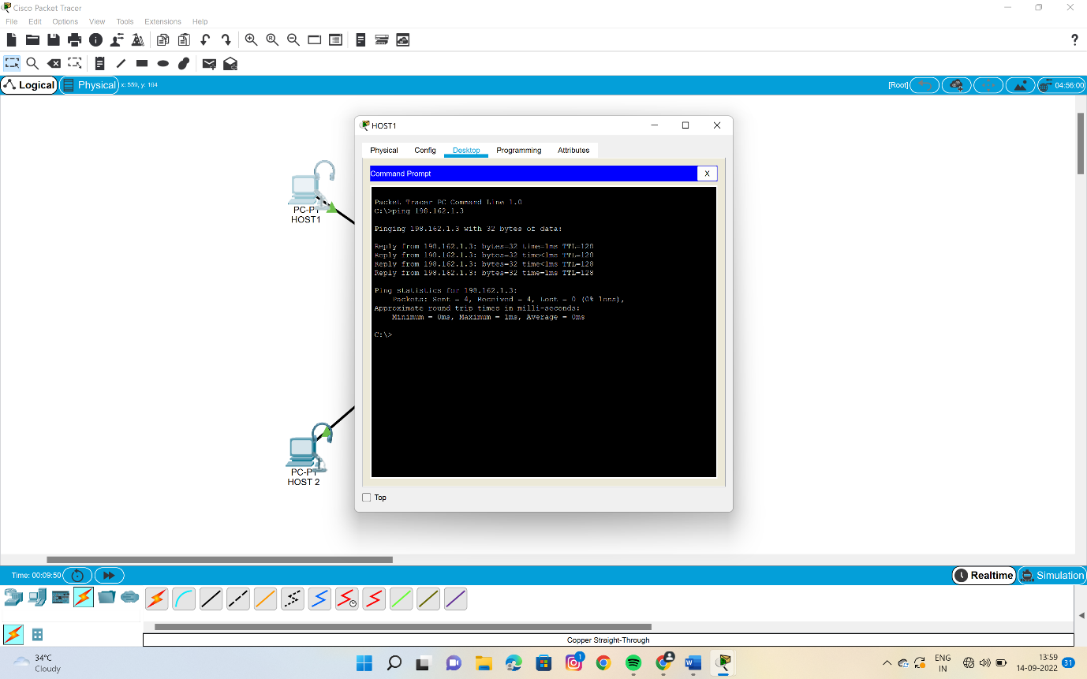

9.if we get reply then what we have done is meaning full and successful……

10.then we can go for the stimulation as shown in the picture .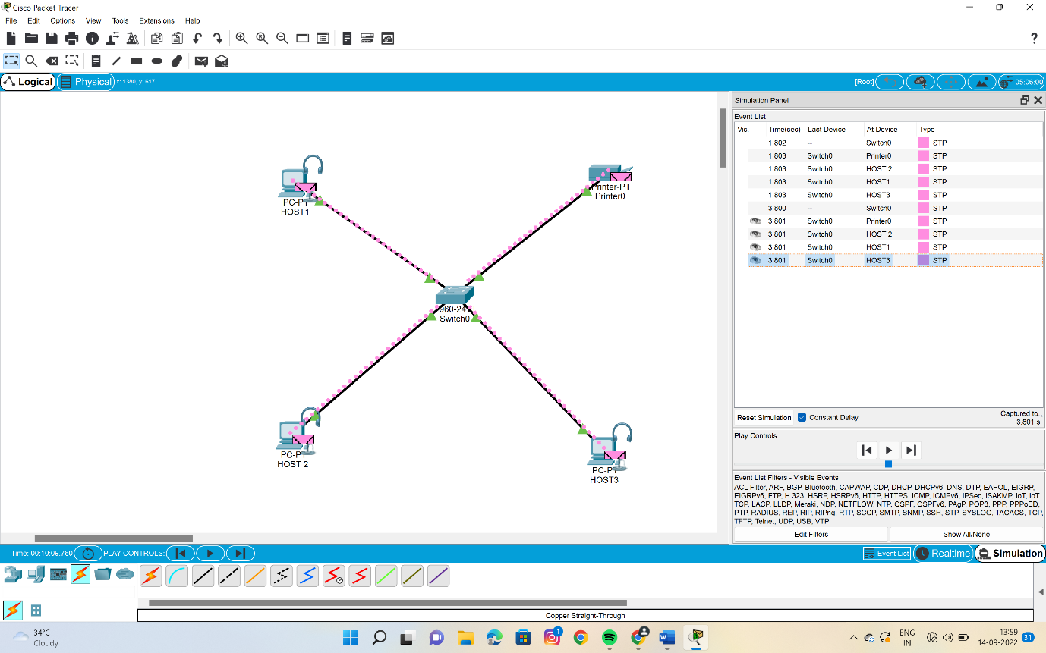

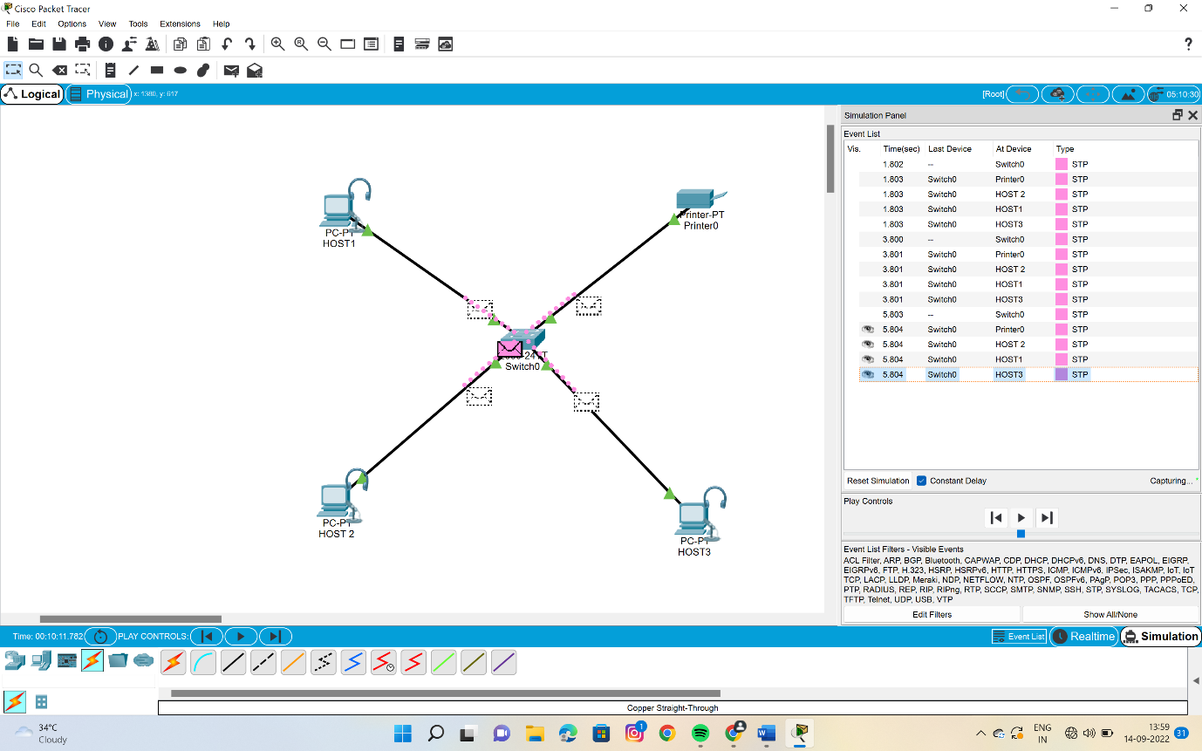

RESULT::

There fore stimulation of multi media networks such as the headphones and the micro phone have been done successfully……